**Running a python script in the background in Windows**

1 ) Rename the .py file to .pyw

That’s an extension for background processes

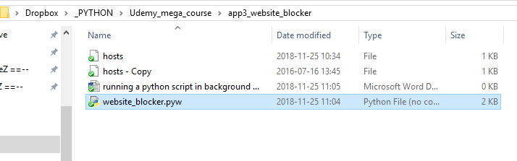

2 ) Run the Task Scheduler



3 ) Click “Create Task…”, add a name, tick “Run with highest privileges”, and “Configure for: Win 10”

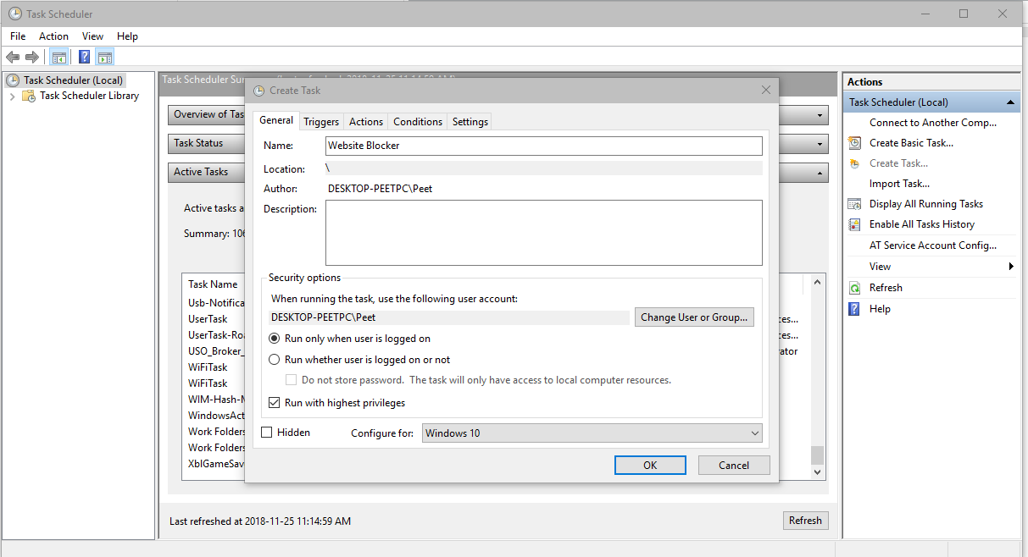

4 ) „Triggers” tab, click „New…”, then „Begin the task: At startup”

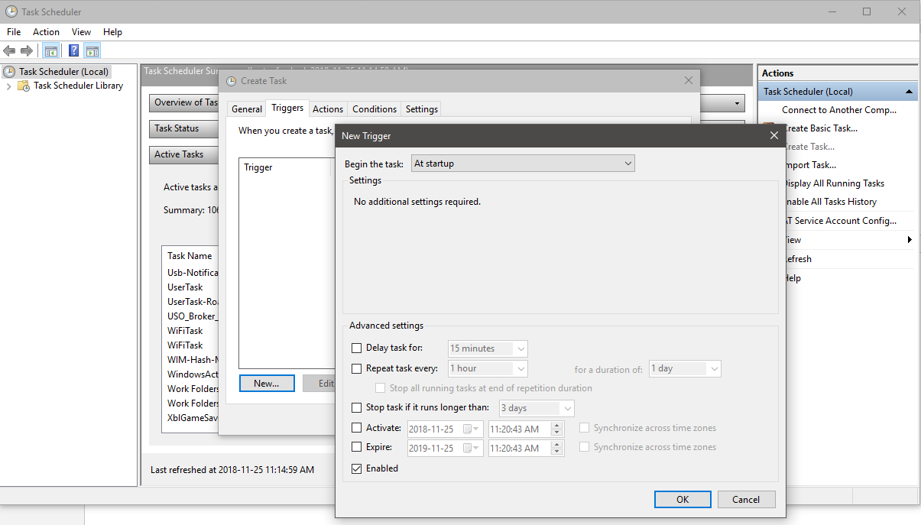

5 ) „Actions” tab, „New…”, then „Start a program”, browse to the .pyw file

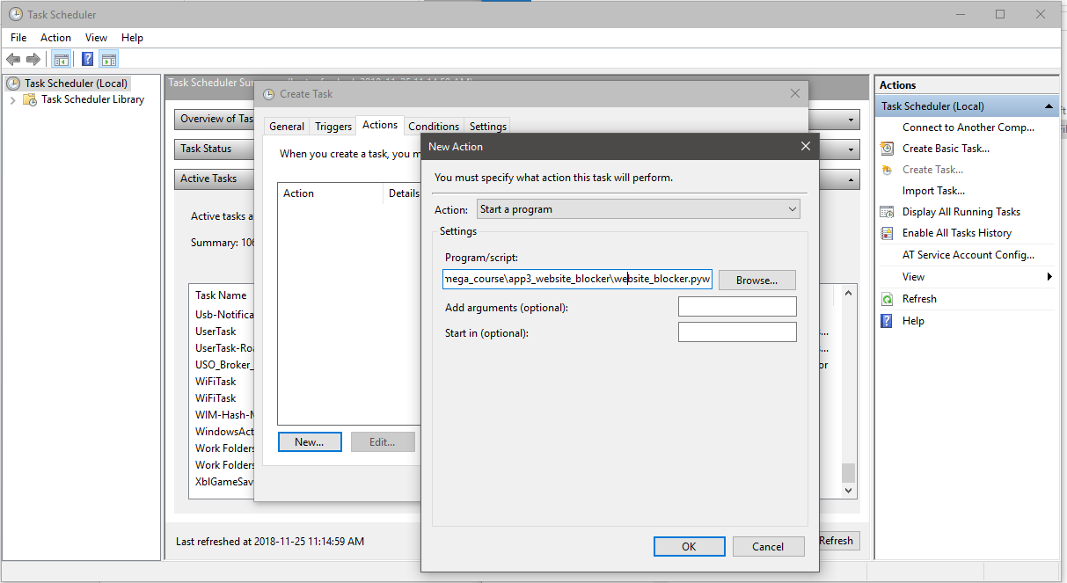

6 ) „Conditions” tab, untick „Start the task only if computer is on AC power”

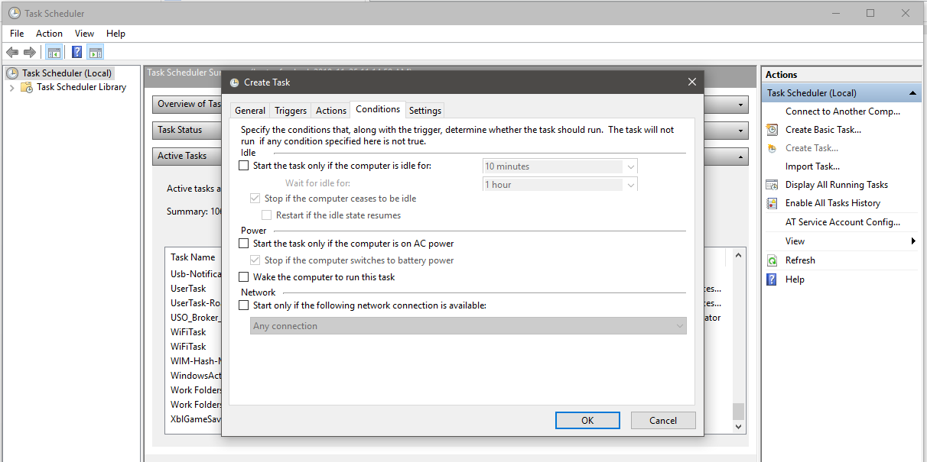

7 ) You can check in the „Task scheduler library” and Run, End or Disable the process

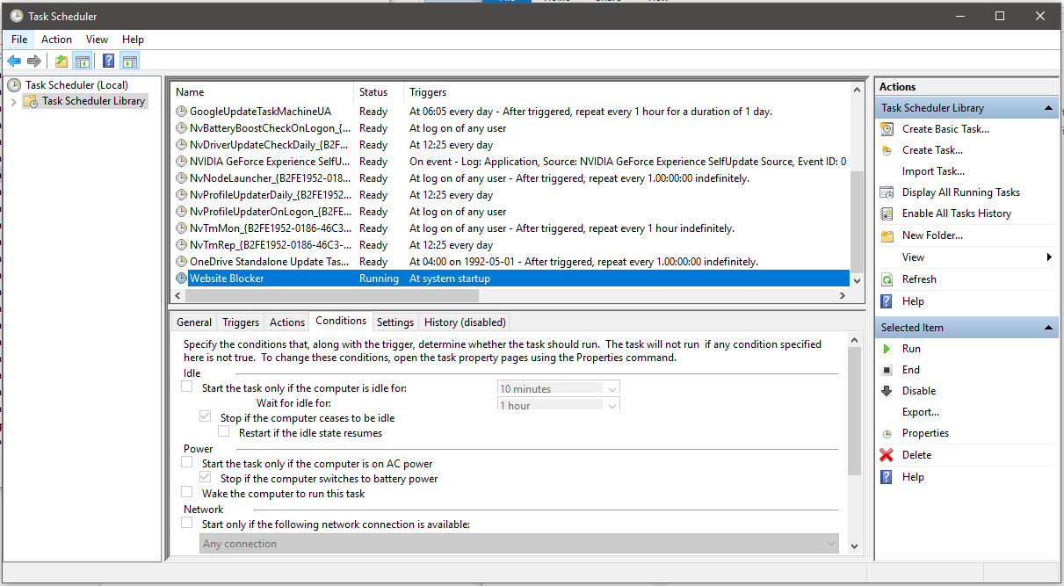

Also check in the Task Manager that „pythonw.exe” is running in the background

